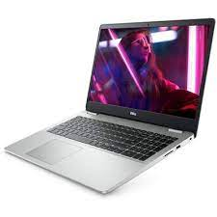

Dell Inspiron 15

* 11th Gen Core I5-1135G7
* 8.MB Cache,To 4.2 GHz
* 4GB, 1x4GB, DDR4
* 1TB 5400 Rpm
* **Rs.108,900**